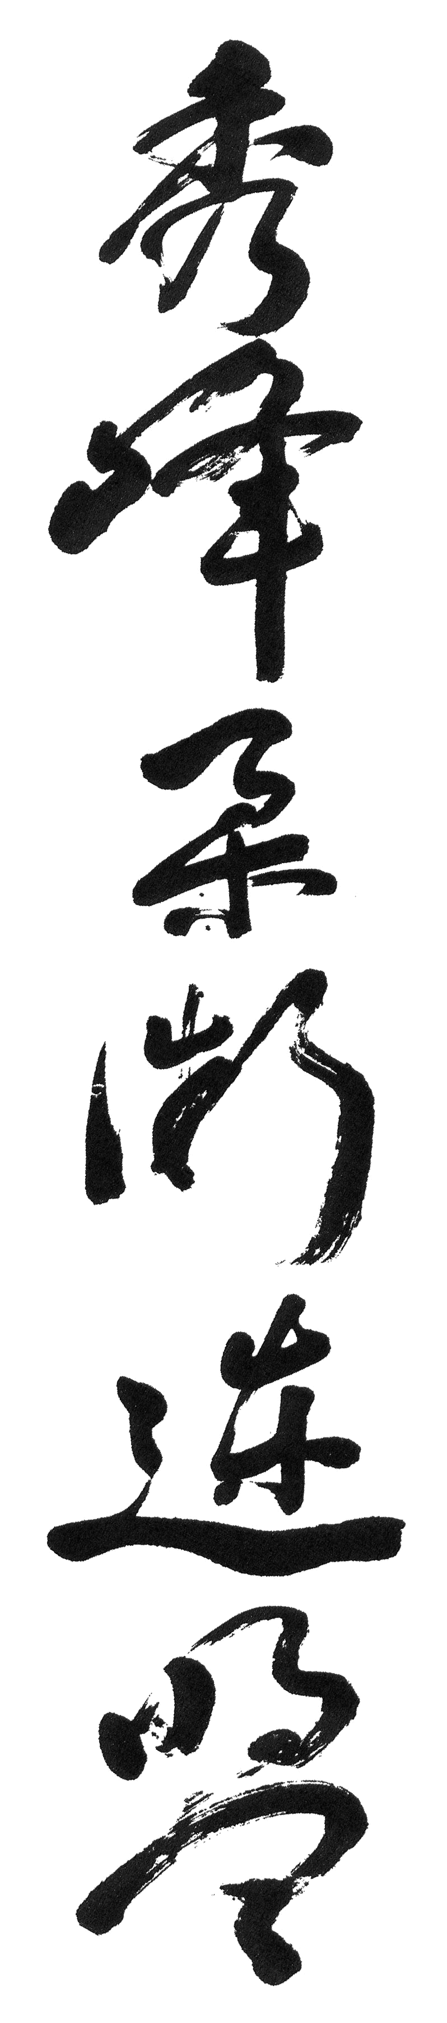
Green Belt (5th Kyu)

Escape Front/Rear with Arms Pinned/Unpinned (8)

Knee Wheel

Bar Chokes (2)

Shoulder Throws (4)

Strangles and Chokes (10)

Rice Bail Throws (2)

Escape from Full Nelson (2)

Front Scissors Throw (2)

Escape from Half Nelson (2)

Locking Techniques on the Ground (15)

Randori

Kumite

